187113

**Goal**

**Regulating the issue of transporting gas cylinders on the University campus**

**Introduction**

Activity at the University requires moving gas cylinders between the various faculty buildings. This usually involves transporting the cylinder from the central storeroom to the different faculties and departments.

**Types of transporting methods**

1. **Short distances –** suitable 4-wheel cart
2. **Long distances** – truck, tender or forklift; the cylinders are tied inside of a special cage that has been adapted for transporting gas cylinders.

**Training movers**

A training course in moving hazardous materials from the Institute for Safety and Hygiene or equivalent institution, with a refresher course and exercise at least once a year.

**Compressed gas cylinders are dangerous for the following reasons:**

1. Chemical danger resulting from the gas in the cylinder which is flammable, an oxidant, toxic, durable, repels oxygen, heat burns or frostbite, choking and tissue damage.
2. Mechanical danger resulting from a cylinder that falls or the high pressure of the compressed gas that can explode and/or be ejected like a missile.

Since each gas has its own risks, it will be transported according to the MSDS safety sheet specific for each type of gas in the cylinder, and in accordance with the risk group (according to the U.N. Orange Book).

**Relevant regulations**

1. Work Safety Ordinance, New Version, 5730-1970, September 1999 edition and its regulations.
2. Work Safety Regulations (Safety and Hygiene at Work with Hazardous Substances at a Medical, Chemical, or Biological Laboratory) 5761- 2001.
3. The Labor Inspection (Organization) Law, 5714-1954 (updated July 1996) and its regulations.
4. Transportation Services Law, 5757-1997.
5. Transportation Services regulations, 5761- 2001.
6. Hazardous Substances Law, 5753-1993.
7. Hazardous Substances regulations (Classification and Exemption), 5756-1996.
8. IS 312 portable gas cylinders: safety rules.
9. IS 312 Part 3 – signs to identify industrial gases.

**Safety rules for transportation**

1. **Gas cylinders will be transported upright (standing)** in a special cage for transporting gas cylinders loaded onto a tender, truck or forklift. The cylinders will be securely fastened and will not bang into one another during transport (see figures below).

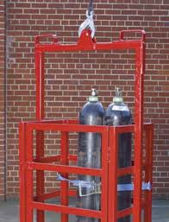 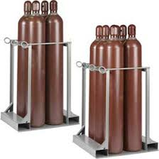

1. **Do not transport cylinders in a closed vehicle**

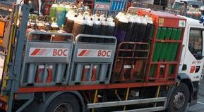[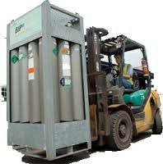](http://www.google.co.il/imgres?biw=1280&bih=588&tbm=isch&tbnid=7ELZyJUBiPspcM:&imgrefurl=http://www.bcga.co.uk/preview/transport_matters.php&docid=8Y2ZVzrmCj5ZAM&imgurl=http://www.bcga.co.uk/preview/images/Transportmatters/transport2.png&w=248&h=251&ei=ksMqU7jlF6nnywPn44GgAg&zoom=1&ved=0CKwCEIQcMEc&iact=rc&dur=866&page=4&start=55&ndsp=24)

1. Separate the gas cylinders according to risk group (according to the U.N. Orange Book).

Sub-group 2.1 – non-toxic flammable gas – such as hydrogen, acetylene, cooking gas, methane.

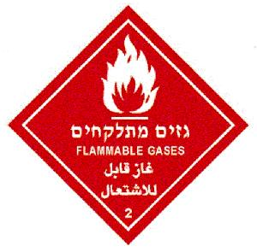

Sub-group 2.2 – Non-flammable compressed gas. For example, inert gases such as helium, argon, nitrogen or carbon dioxide.

[](http://en.wikipedia.org/wiki/Image:HAZMAT_Class_2-2_Nonflammable_Gas.png)

Sub-group 2.3 – Toxic gas. For example, nitrous oxide (N20), phosphine, arsine, ammonia, fluorine.

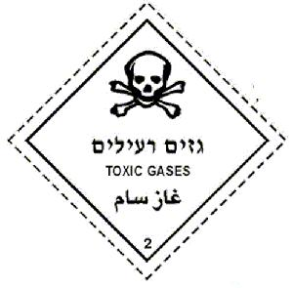

**Note:**

**Oxygen is classified as a non-flammable and non-toxic gas, sub-group 2.2, but also classified in a secondary group as an oxidant (sub-group 5.1). Do not transport an oxygen cylinder with flammable gas cylinders (sub-group 2.1) or toxic gases (group 2.3).**

1. Do not transport a cylinder that is not identified.
2. Do not transport a gas cylinder that is damaged, rusty, missing a valve, missing a protective cap.
3. The cylinders will be offloaded only by lowering the cages using a forklift, crane or suitable hydraulic ramp.
4. Workers transporting the cylinders will be given comprehensive safety training on transporting and handling hazardous substances incidents, including refresher courses and exercises at least once a year.
5. For short distances, the cylinder will be moved from place to place using a 4-wheel cart, with the cylinder securely fastened to the cart and a protective covering placed on the valve (see figure).

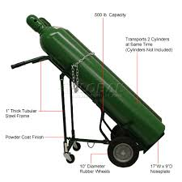

1. During transport the cylinder valve must be covered with a protective cap that has been securely screwed in place.
2. Do not move a gas canister in a passenger elevator with passengers inside.
3. Transport in an elevator will be solely in a service elevator or an empty passenger elevator.
4. In no case may the gas canister be dragged, thrown or rolled.
5. Do not lift up the canister by its protective cover.
6. Do not lift or move canisters using an electromagnetic crane.
7. To transport the canisters, they should be arranged so that all valves will be facing one direction.
8. Use personal protective equipment – safety shoes with steel cap protector, safety goggles and face protector when disconnecting and connecting the canisters.
9. The transport vehicle must have personal protective equipment for the workers – gas mask with a filter suitable for the type of gas, gloves, first aid kit and fire extinguisher.
10. The transporter must be familiar with the safety sheets for the canisters, and keep printed copies.
11. Smoking near the canisters is prohibited.
12. Keep canisters away from heat, flammable materials, corrosives and oils.

**List of required safety equipment**

First aid equipment and personal protective equipment for the driver.

1. Dry powder extinguisher according to Israel Standard 1017.
2. **First aid kit that includes:**

|  |  |
| --- | --- |
|  | **Units** |
| 1. Portable breathing mask | 1 |
| 1. Non-sterile surgical gloves | 3 pairs |
| 1. Personal field bandage | 3 |
| 1. Bandage for burns | 1 |
| 1. Fabric sling | 6 |
| 1. First-aid scissors | 1 |
| 1. Light stick | 1 |
| 1. Gauze pads 33b | 10 |
| 1. 4” bandaging tape | 4 |
| 1. Bandaids | 10 |
| 1. Polydine skin disinfectant sponge | 10 |